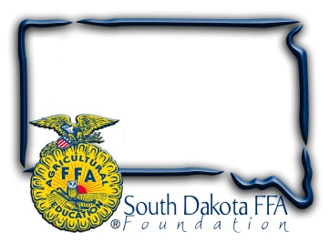
For Immediate Release
Contact: Gerri Ann Eide
605-765-4865
Gerri@sdffafoundation.org

FFA members package 50,124 meals during Living to Serve Day
(Bath, SD) – April 27, 2022– The blue corduroy jacket is a familiar symbol of the FFA organization, worn as part of official dress during most FFA activities. On April 25th at the South Dakota FFA convention in Brookings, as part of a SD FFA Living to Serve Day, members removed their jackets and rolled up their sleeves to help stop hunger.
This service project, supported by Pioneer-Corteva and Feeding Brookings, exemplified the portion of the FFA motto which states “Living to Serve” by teaming up with industry to fund a Meals of Hope, hands on project that combats hunger. SD FFA members and Pioneer-Corteva staff measured, poured, sealed, and boxed 50, 124 meals in assembly line fashion throughout the day-long event. Members stopped in between workshops and competitive events throughout convention and left the event knowing that by giving a few minutes of their time they would make a significant difference in the life of a person less fortunate then themselves.
For just$.28/meal, Meals of Hope food packages include a hardy Beans and Rice Casserole (rice, pre-cooked dried beans, soy protein, 6 dried vegetables and 21 vitamins and minerals). Some of the 50,124 meals were taken home by FFA chapters for their local food pantries, and the rest will be distributed across SD through Feeding South Dakota and Feeding Brookings. Jennifer Stensaas with Feeding South Dakota says "We are very grateful for our partnership with FFA and Meals of Hope and for securing these meals to feed those who are facing hunger in our state." Meals of Hope recognizes the need to start with charity at home, and focus on offering more than nutrition, providing a bit of hope to carry those in need through another day.
“The FFA organization believes strongly in the fourth line of the FFA Motto "Living to Serve", which is why we are very excited to receive funds from both Pioneer-Corteva and Feeding Brookings as well as day of event manpower assistance and interaction from their staff,” says Sandy Osterday, SD FFA Foundation President. Osterday shares, “The event gives students the opportunity to work together with FFA members from across the state to make items that will help those in need. Knowing we are helping those in need across our state is a great feeling.”
The SD FFA Foundation is proud to support Agricultural Education and the FFA's mission to make a difference in the lives of students by developing their potential for premier leadership, personal growth and career success through agricultural education. For more information about the South Dakota FFA Foundation and South Dakota's FFA programs, visit www.sdffafoundation.org or follow us on Facebook.
Photos: FFA members from across the state work together to measure, package and seal meals for Day of Service Meals of Hope Project at State FFA Convention.
# # #

